**Cyberguard Course Search User Guide**

This guide assumes that you are starting completely fresh, however, even if you are not completely fresh, this guide may help you completely set up the program for your own use.

Step 1: getting the files

First, navigate to GitHub and find the CyberguardCourseRegistration project. You will be looking for a webpage that looks something along the lines of the image below.

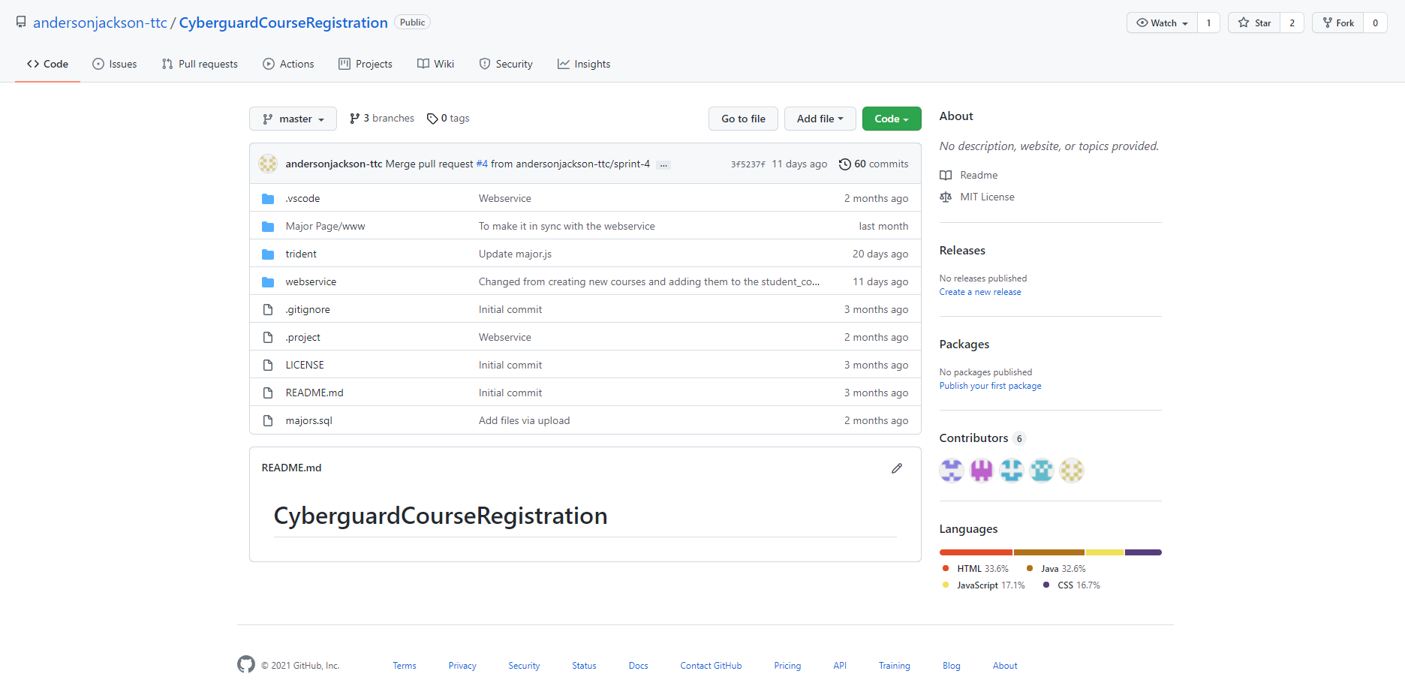

Next, hit the green code button to the right of the go to file button, then click Download ZIP as shown in the figure below.

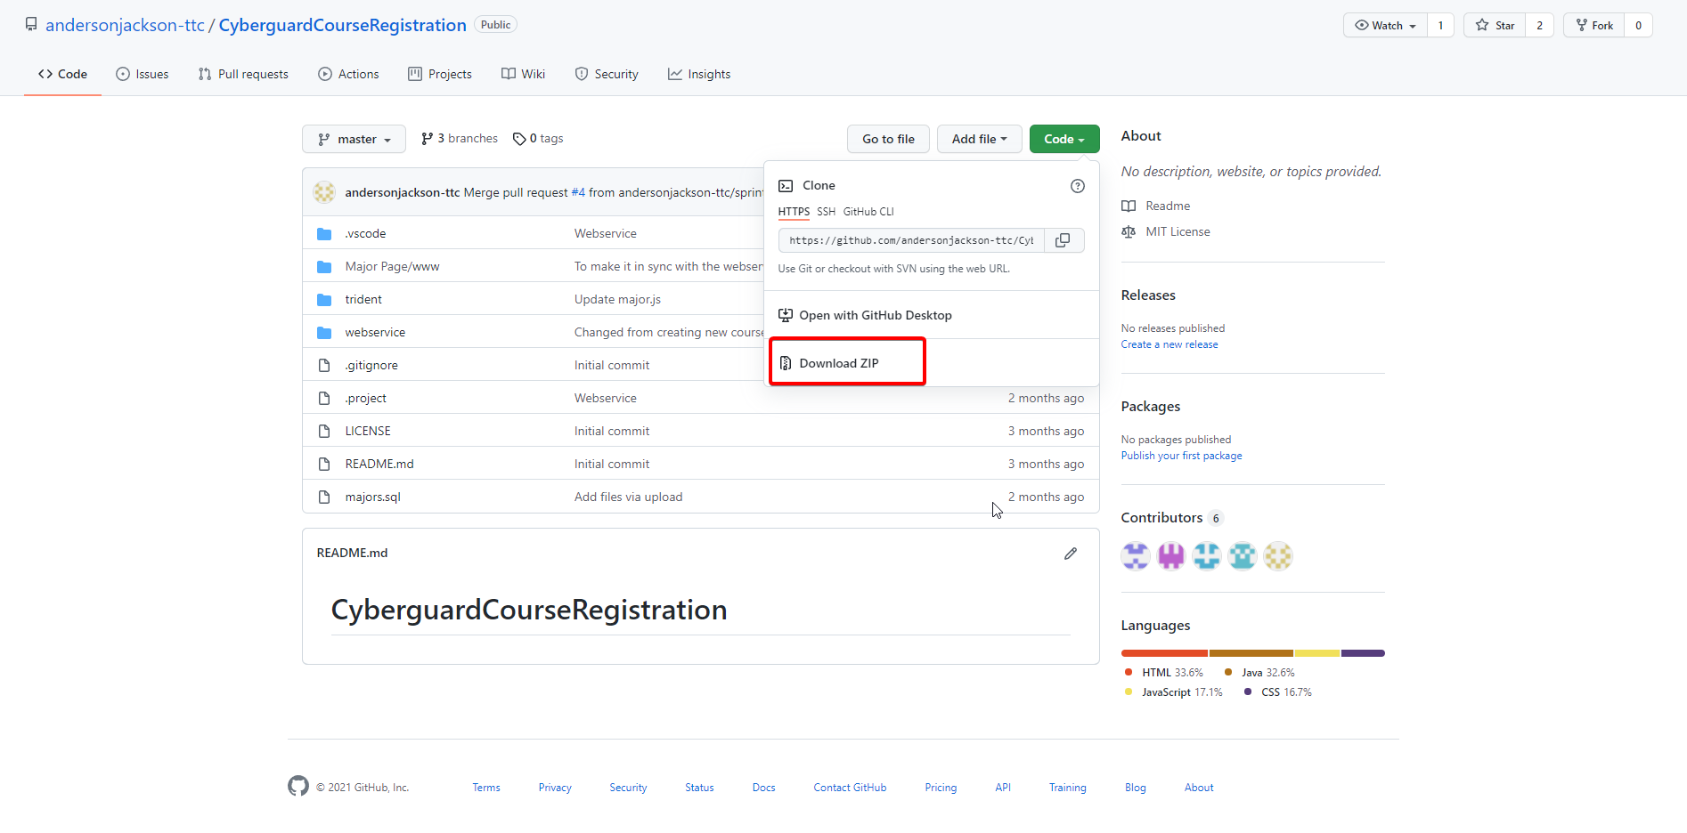

Step 2: setup

You will need 2 programs at the very least in order to get this project running, eclipse (or similar java IDEs), and Xampp (or similar services)

The reason you will need a java IDE is that the project’s backbone is mostly written in Java, and to execute the project, you’ll need a program capable of handling maven and java applications.

The reason you will need XAMPP or similar services is so that you can host the sql/php server in order to create and work with the databases used in the course search.

Assuming you did a default install on both, the xampp application should look something like this

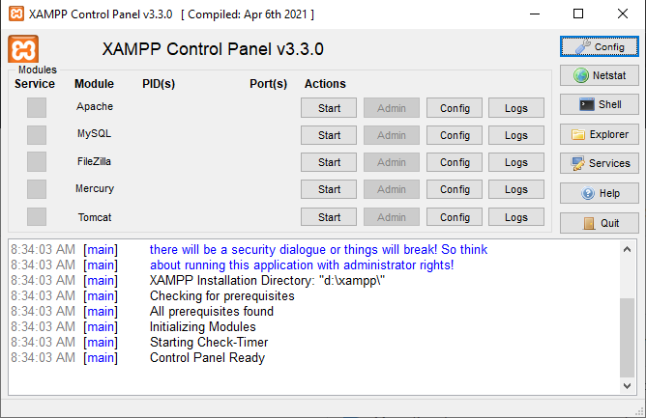

Here, you’ll want to click START on the apache and mysql modules. To confirm they have started, you can navigate in your browser to <http://localhost/phpmyadmin/>

And if the webpage loads, then you’re good to go.

Next, comes eclipse

Upon opening and running eclipse, the program will ask about workspace, it’s simply best, in this case, to allow it to create the workspace in whichever disk you have the most space available, and leave it at that.

Now once the program has loaded, you’ll want to click FILE > OPEN PROJECTS FROM FILE SYSTEM

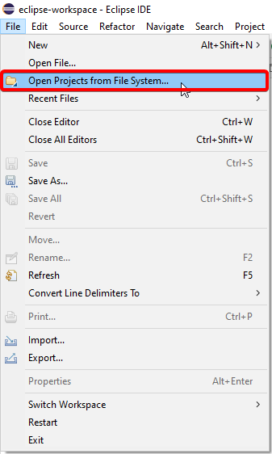

This will open up a window, that looks like this 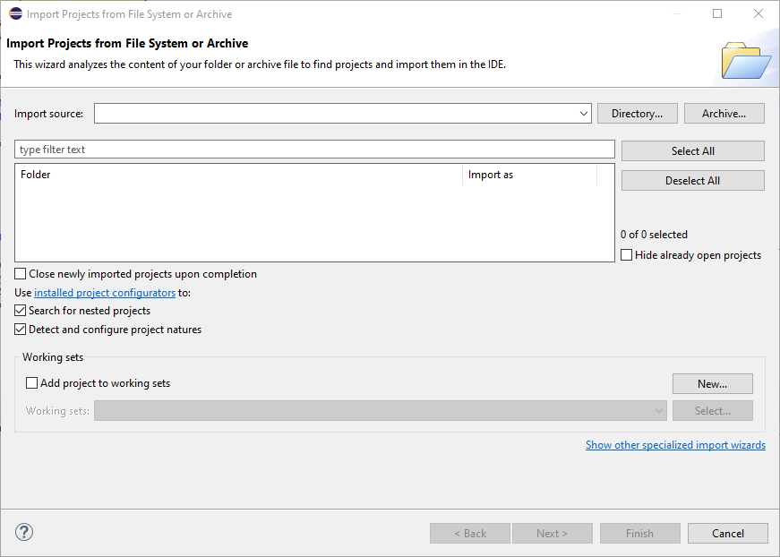

Click the directory button, and navigate to where your (hopefully extracted) folder is that you downloaded earlier, then double click the webservice folder, then hit select folder

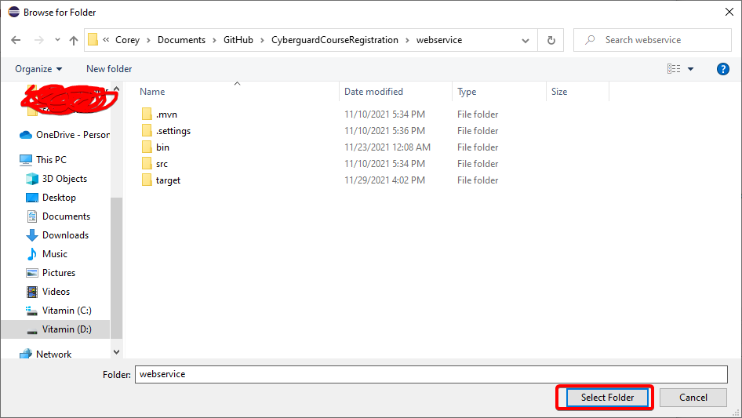

Once this is done, the project should appear in the package explorer.

Step 3: Running it.

In order to run the project, you need to have that xampp mysql/apache modules started. This is the only real prerequisite.

First, in eclipse, expand the webservice folder by clicking on the arrow next to it in the package explorer.

Then, right click on the webservice folder, and click run as > maven clean

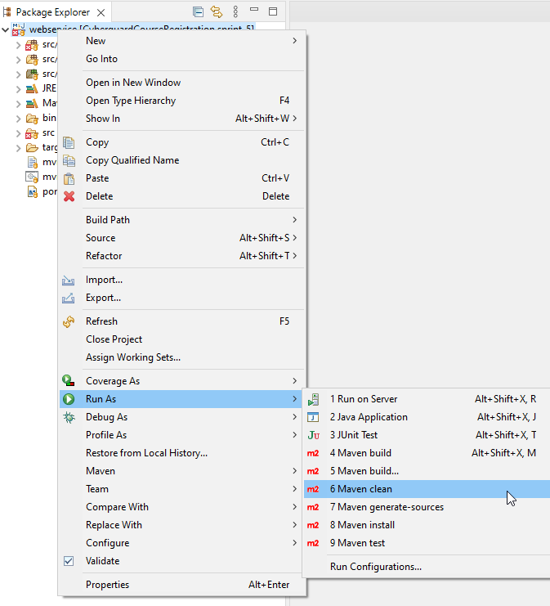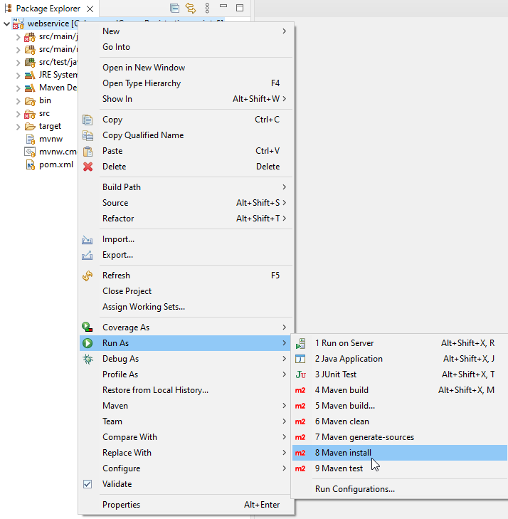

Once this runs, assuming there are no errors on the user’s end, you will right click and then run as > maven install as seen above.

And lastly, assuming that you’ve once again received no errors, you will right click on the src/main/java folder, then run as > java application as seen below

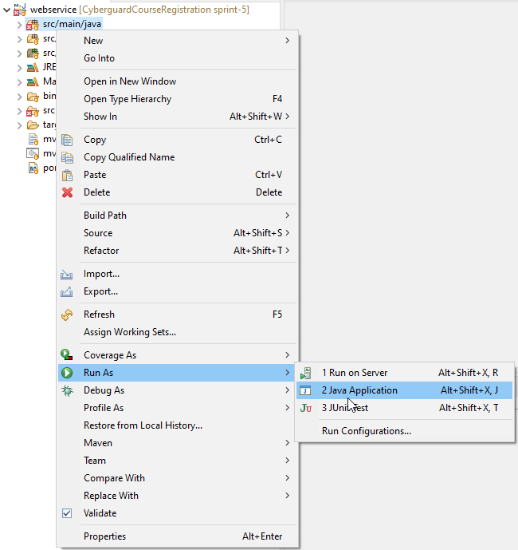

Once this has been done, you can navigate to localhost:8888 in order to see the fruits of your efforts to run the program!

